Collecting User Acquisition Data Through all Channels

Website/SEO Assignments

NAME: Tahiya Rahman

horizontal line

# About the Data

The purpose of the paper is to find out trends in User Acquisition data to understand the trend for week in NSTEM website users and their behavior and conversion if it has positive influence or shown correlation in the ana;ysis paper. The data will show the potential best channels for the user acquisition.

Data Overview: April 9th, 2023 - April 16th, 2023

Most users are getting the website information through organic search and Direct marketing. From the Direct & Organic search & Referral overlap visually tells that the channels have a great influence over the audience of NSTEM.

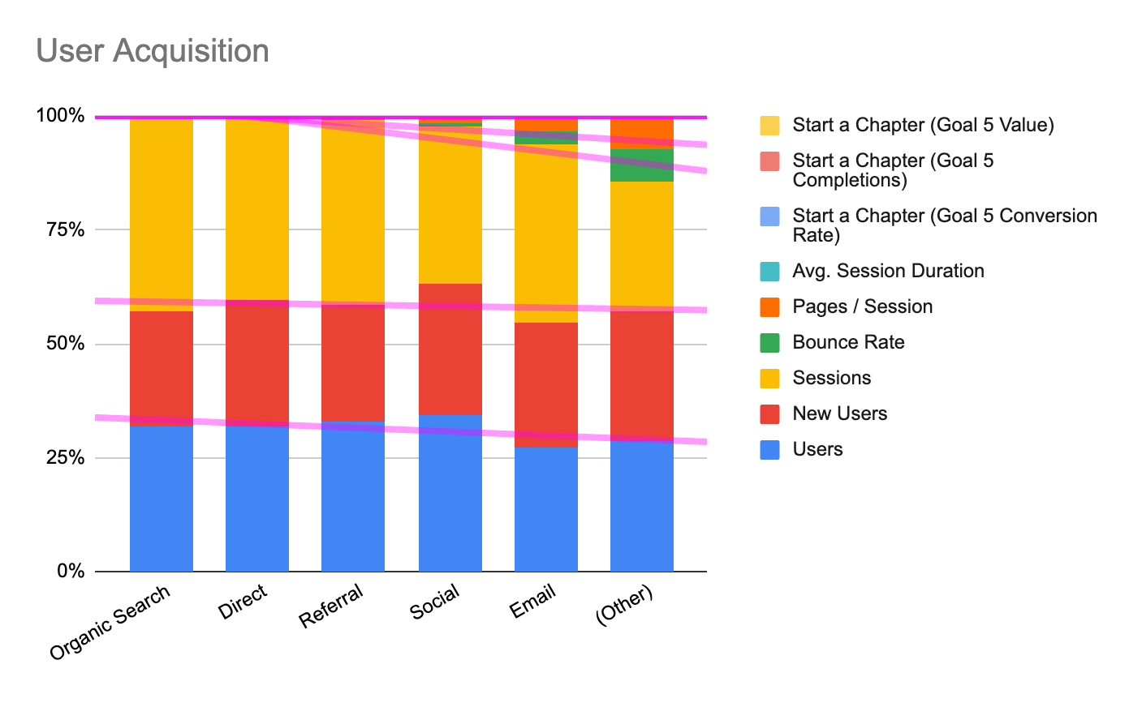

* Besides, organic search and direct mediums, referrals are also in a detectable shape and it is performing within the first two. Trendline defines the best performers who are above the line performing and the under performers are shown under the line.
* On the other side, there is a significant rise in the number of new users with Organic search & How to Start Chapter Page Visit (Goal 1 Completions) in NSTEM website.

# What NSTEM Should Continue Doing

* NSTEM Should introduce more subjects and create more referral links to increase the commonality between the channels. So, there will be more audience who can engage through different channels and thus NSTEM can increase its positive exposure and reliability.

# Ways to Improve the Website

* NSTEM can make improvements through Multi Channel Funnel Reporting (MCF).
* Create Custom Reporting about NSTEM audiences and sessions.
* Can create more segmentation for the audience base to get more insights.

# Data that Stands Out

From the analysis, the user acquisition is more Organic search and Direct Marketing driven for NSTEM. In general, the users are more protective towards the email as it is considered as one of the personal communication methods. Due to this reason, email marketing can lag.

**Conclusion**

To conclude, the most powerful channel to acquire more users is Organic search.

Google Sheets:

<https://docs.google.com/spreadsheets/d/1SJ4eyKdCfqvD4lv22aP0DRusPySoQ-byRxsgmx0eO6M/edit?usp=sharing>